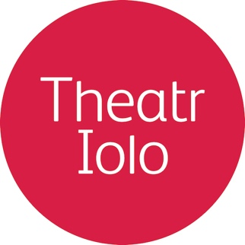
Theatr Iolo is the leading Welsh children’s theatre company, creating high quality experiences that are stimulating, surprising and meaningful for children and their adults.
……………………………………………………………………………..……………………………………………………………………………..……………………………………………………………………………………………………………………………..

Theatr Iolo Producing Presentation

Theatr Iolo is a producing theatre company, which means that we create and make shows that can be performed at a variety of venues. We can offer groups presentations on what it is like working in the arts industry at present, focusing on any particular areas you would like; Marketing, Touring etc.
We can also deliver a presentation that will give your group a deeper understanding of the producing process as a whole, which explains the steps involved in developing an idea or script and turning it into a full scale production.
All presentations will be accompanied by a Question and Answer Session, where your group can ask us as many questions as they like.
These presentations can take place digitally (live or pre-recorded) or in person.
Cost: £100 for a presentation of this nature, including free handouts
Duration: 1-2 hours

……………………………………………………………………………..……………………………………………………………………………..……………………………………………………………………………………………………………………………..
If you want to find out more about any of these opportunities, then drop us an email hello@theatriolo.com or give us a call on 029 20613 782

