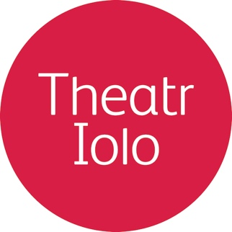
Theatr Iolo is the leading Welsh children’s theatre company, creating high quality experiences that are stimulating, surprising and meaningful for children and their adults.
……………………………………………………………………………..……………………………………………………………………………..……………………………………………………………………………………………………………………………..

The Environment Expressive Arts Workshop

The group will start the workshop by taking part in a series of warm up exercises to prepare themselves to use their bodies and voices as a medium of expression. During this warm up period, the group will discuss what they already know about the environment, and what challenges arise when trying to save the environment from threats such as global warming.
Following the warm up and discussions, the group will take part in several activities designed to explore important ideas and messages to consider when thinking about the environment and how to protect it.
After these exercises the group will be split into several smaller groups, who will attempt to express these ideas through more ‘performance-based’ methods. A possible exercise could be:
- Every group is asked to imagine that they are a tribe of people who have discovered a way to be kinder to/to save the environment.
- Their task is to communicate their idea to another group/tribe. The problem is, these imaginary people don’t speak the same language.
- Every tribe has their own language based on vowel sounds. Each tribe uses a single vowel to communicate (for example, one tribe uses only the ‘ah’ sound to communicate, another tribe uses only the ‘oh’ sound, and so on).
- This is the only sound they’re allowed to make to communicate their idea to the other tribe. Writing is also forbidden. The groups will be actively encouraged to explore other ways to communicate, through physical story-telling and working as a team.
The purpose of such an exercise would be to provide the smaller groups with the opportunity to explore different, unconventional ways of communicating messages and ideas relating to the topic.
Following this kind of exercise, we would move on to the main objective of the workshop, which is to create and ‘perform’ a story based on ‘The Environment’. By using the ideas and forms of communication already explored earlier in the workshop, the groups will be encouraged to collaborate to create a single story. The aim would be to focus on local issues but relating them to a global message relevant to us all. Hopefully by the end of the two hours a ‘performance’ element will be seen where each small group contributes their ideas toward a clear narrative told by all involved.
Cost: £350 for this workshop and all resource materials
Duration: 2 hours
……………………………………………………………………………..……………………………………………………………………………..……………………………………………………………………………………………………………………………..
If you want to find out more about any of these opportunities, then drop us an email hello@theatriolo.com or give us a call on 029 20613 782

