MUCKERS
EDUCATION PACK / PECYN ADDYSG
Theatr Iolo is the leading Welsh children’s theatre company, creating high quality experiences that are stimulating, surprising and meaningful for children and their adults.

……………………………………………………………………………..……………………………………………………………………………..…………………………………………………………………………………………………………

Theatr Iolo has been at the forefront of theatre for children for over thirty years, delivering performances and workshops to babies, children, teenagers, parents, pupils and teachers across Wales, the UK and internationally.
We create and produce the best work for children and young people to help them make sense of the world around them and their place within it. We work with the best artists, writers and creatives, to ignite creativity and imagination in both English and Welsh languages.
Theatr Iolo’s values are;
- Trust: When you come to a Theatr Iolo production, you can trust your experience will be of the highest quality. You can rely on us to feel included, be inspired and entertained.

- Ambitious: We would like you to feel challenged and hope to help you to explore relevant issues that you face and deal with. We want to help young people open up and learn about themselves and the world in which they live.

- Collaborative: We want to reach as many young people as possible and particularly those that have not had access to live theatre before. We want to create work that is relevant to young people and strive to understand and represent the diverse nature of those stories.

- Creative: We want to ignite creativity and imagination in all the children that we reach and work with, in both Welsh and English languages. We want to offer the most creative, stimulating and surprising opportunities that challenges expectations.

- Authentic: We aim to represent children from all backgrounds and life experiences and deal with current challenges our audiences meet in their lives. We aim to remove barriers to attendance and strive to offer genuine and inclusive opportunities.

……………………………………………………………………………..……………………………………………………………………………..…………………………………………………………………………………………………………

Theatr Iolo wants to help make your visit to the theatre an enjoyable and useful experience for all. We have created this education pack in order to help you prepare your students before your visit and to follow up with exercises after your visit.

This pack is designed to fit within the new Welsh curriculum. It has been written as a tool that can be used for your unique group and has elements that support all four purposes.

There is a direct correlation with the learning areas Expressive Arts, Health and Wellbeing and Language, Literacy and Communication and exploring drama techniques, role play and performance. We will be focusing on these areas throughout this pack.
Each themed section starts with how it relates to the stimulus, and the main aims and objectives for each exercise.

However, the pack can be used to tease out elements from the other learning areas, and exercises can be developed supported digital competency. For additional suggestions on how to do this, please email hello@theatriolo.com

N.B. The expressive arts are great tools for accessing and improving wellbeing. Sometimes however they can bring more to the surface than bargained for. If you need support, consult your designated safeguarding officer.

CONTENTS:

Introduction P. 4-5

BEFORE THE SHOW exercises P. 6-7

POST PERFORMANCE exercises P. 8-16

Critical Feedback and Evaluation P. 17

Common Questions and Answers P. 18-19
Introduction

Presented by the egg, Oxford Playhouse, Theatr Iolo & Conde Duque
MUCKERS
By Caroline Horton
Devised in collaboration with an international ensemble

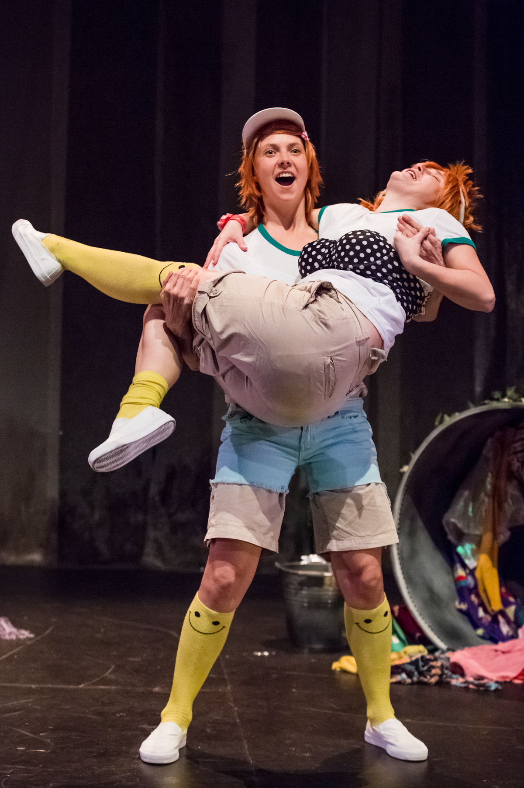

Muckers
Plural noun
1. persons who deal with (and/or delight in) dirt
2. old friends or soulmates
3. rough or coarse persons (dated use)

Paloma has always mucked about with Pichon. They dress up like tigers, flamenco dancers, queens, kings, rabbits and Lady Gaga. Until one day a blinding white light lands on Paloma, and her days of dressing up, running wild and mucking about seem to be over…

Created by award-winning theatre maker Caroline Horton and an international ensemble, Muckers is a quest for self-acceptance, with original songs and a little bit of Spanish. Side splitting and poignant in equal measure, it brings us face to face with the curious invisible forces which are acting upon us when we don’t even know it. Join Paloma on a magnetic, captivating and mucky journey…

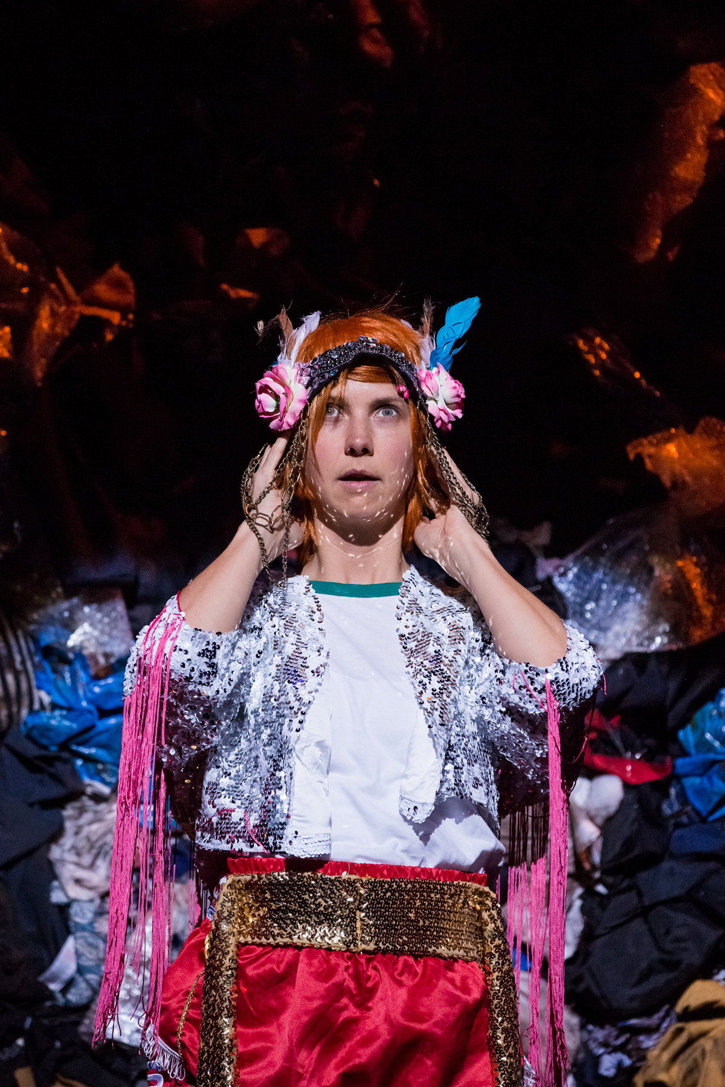
Background on Caroline Horton

Caroline is an award-winning artist based in Birmingham. She is an associate artist at Birmingham Rep and the first BBC Birmingham Writer in Residence.

She spends most of her time as Caroline Horton & Co making her own theatre projects as an autobiographical writer/performer. Recent projects include: You’re Not Like The Other Girls Chrissy, Mess and Islands that continue to tour the UK and abroad. She is currently developing a new show All Of Me.

Her work is fun, stupid and profound - often autobiographical - sometimes political.

Why is Muckers relevant in the UK?

Muckers is a perfect springboard for schools to develop their compulsory teaching of British Values, which include Equalities Law, mutual respect, individual liberty & tolerance, whilst also helping to reduce incidences of gender-related bullying. Educationalists are habitually tackling issues around ‘outcomes for girls’, which are still suffering from perceptions of what they can/should & cannot/shouldn’t do.
The play explores how the characters develop self-knowledge and courage - crucial qualities that support learner resilience.
The dual-language production promotes further tolerance and harmony between different cultural traditions by enabling students to acquire appreciation and respect for their own and other cultures.
“We need to understand how scarcity affects the way we lead and teach, we have to engage with vulnerability and we need to learn how to recognize and combat shame. What would it mean for our schools and classrooms if we showed up for tough, honest conversations about what it takes to bring our best, most authentic selves to work? These conversations may sound risky and vulnerable, but risk and vulnerability are essential to courageous schools. A daring classroom is a place where both teachers and students commit to choosing courage over comfort, choosing what is right over what is fun, fast or easy and practicing values rather than professing them.”

Brené Brown | Daring Classrooms | SXSWedu 2017

Before you watch the show…

We recognise young people as intelligent individuals and learners. We do not want to pre-load them with information they will gain through participating as an audience member.

Instead, we think it is more fun and effective to set some groundwork stealthily, using their imagination and game play. This can provide them with the necessary tools to access theatre experiences as creative individuals.

And remember, sometimes it’s ok for a game to just be a game, so these two Warm Up Games are the perfect way to get your group ready for Muckers…

Game 1…

This is not a …
Choose a simple object. For example, a beanie hat.
This hat will be passed around a circle. Each person is invited to state ‘this is not a hat, it’s a …’ and they then create an alternative reality for the hat.

- A sack for fairy dust
- A ghostbusters ghost trap
- A black hole
- A washing machine
- Mary Poppins bag!

As the statement is made, also encourage a physical demonstration of how the hat is that new thing.

*** Links to the Curriculum: Communication and Language ***

This game is great to stimulate imagination and creativity.

Game 2 …

Boss’ Footsteps: ULTRA

Before we reach the ULTRA version of this game, cover the basics.

Someone is the ‘Boss’ who stands at the far end of the room, with their back turned to the rest of the group. The rest of the group stands at the opposite end of the room in a line. The idea is that they have to sneak up on the Boss. But at any point, the Boss can turn around. When they do, everyone has to freeze!
Anyone seen moving by the Boss is sent back to the beginning again. The game ends when someone reaches the Boss unseen, and gently taps him or her on the shoulder. The winner then becomes the Boss.
You make the game ULTRA by adding a piles/rows of costumes, or items into the pathway of those creeping up on the Boss. Now each person must put on two or three items from the floor before reaching the Boss. If they are seen moving at any point by the Boss, the items must be removed, placed back on the floor and the players return to the beginning.
NB. Avoid saying the words ‘dress up’ at any time before or during the game.

*** Links to the Curriculum: Expressive Arts ***

This game is great for quick thinking and focus.
It offers a sense of purpose without ever being ‘out’.

Post performance exploration

Once you have seen the show, you can now carry out some post show exploration.

These exercises can be tailored to different age groups. Our suggestions tap into the key themes and ideas from Muckers. These can be explored as individual sessions or brought together as a bigger session.

Muckers explores how we learn to stand proud and be true to ourselves. The themes include;

- Feminism
- Friendship
- Shame
- Cultivating Bravery
- Empowerment

...all through the power of play.

……………………………………………………………………………………………………………………………………………

Theme: Play

Muckers uses the art of play to explore themes.

What is play? Play is what people do when they follow their own ideas and interests, in their own way, and for their own reasons. Play is how we make sense of the world. Play is how we push boundaries. Play is how we confront our fears, worries, and insecurities, and play is how we free ourselves of them.

If we ask each other to define play, often we define it as something children or young people do. But it should be something we all do.

A form of play is clowning.

Clowning
Clowning techniques are used throughout Muckers. These techniques are how the actors build their connection with the audience and supports the journey of the characters.

Clowns teach us to be brave, to fail again and again, to listen to our audience and use our imagination

When we talk about clowns, a lot of people will have strange visions of painted faces, baggy trousers and oversized shoes. Some may even say that clowns are scary. But think about what clowns actually are – who has been called a clown? Or called someone else a clown? What were they doing? Playing the fool? Making us laugh?

A clown plays.
They play to make us laugh.
They play with our expectations.

They play with rules, big rules, little rules, all rules are up for bending and breaking by clowns. That’s possibly why some people find them a little scary. We don’t know what they will do next, they often tell us the truth when we’re not ready for it, and they almost always refuse to behave ‘properly’. It can be unnerving to be around a clown, it’s probably why it’s a little scary to be asked to be a clown.

But to be a clown is about freedom. It is about knowing the rules, but not having to follow them. It is about totally accepting yourself, here and now, with no “then” and no “next”. It is about bravery. The bravery of doing all that and inviting us in to join you. But most of all, it is about laughter, fun, play.

Clowning Exercise

Move around the space. Fill all areas. Try not to follow others and avoid circles.
With eye contact, you now have:
- 60 seconds to shake hands with everyone in the room and say ‘hello’
- 40 seconds to (gently) touch knees with everyone whilst saying your name
- 20 seconds to fist bump everyone whilst saying their name.

A useful and important rule for Clowns is Clocking.
Clocking is the act of looking directly at the audience, and allowing them to share in our world, right now, in the moment.

*** Links to the curriculum: Health & Well Being, Communication ***
- Awareness of others
- Build relationships
- Communicate clearly

Connection to Muckers: Clowning techniques are used throughout Muckers.

The Clapping Game

One person volunteers to leave the room. The others, the audience, decide what task they want that person to achieve when they return. Keep it very simple at first like standing on a chair, taking a bow, picking up a coat etc.

The objective of the game is for the person on stage to complete the action that the group has planned. As they experiment and try to find out what the planned task is, the audience clap when the person is doing something correct. If it is not part of the plan, the audience stop clapping.

If the plan is to stand on a chair, the audience clap from the point the person enters the room as they walk across to the chair and stand on it. If the person deviates from this at all, the audience stop clapping, and the person tries something else.

No other means of communication are allowed. If the person gets stuck, it can be useful to send them back to the start, so they experience clapping again and boost their confidence.

This game is ideal for audience-contact as its impossible to play it effectively without listening to the audience. It’s basically the children’s game warmer/ colder.

You don’t have to be funny or have brilliant ideas. You just have to communicate with the audience.

Now, talk about the flop. Clowns want to find the funny. But sometimes we fail to find it, or keep it, and we can feel the audience lose interest in us. This feeling is called the flop. It is nothing to be scared of! Everyone and everything flops at some point or another! The flop is actually an opportunity to stop what we’re doing and try to jump back to something we did earlier that felt good.

Often we flop even though the audience found what we were doing funny. And we don’t know why. We might respond normally with a “but – “ or “why?”, an embarrassed giggle, or a nervous look at our feet. With clowns, we call this bafflement. It can be angry, sad, incredulous, whatever it is will be unique to you.

The challenge is, in the moment you realise the flop is happening, to share your bafflement with us. We will love you for it. Everyone ‘fails’, but it’s only failure if you let it stop you.

**Links to the curriculum: Expressive Arts, Communication**
- Communication and Teamwork
- Relationship between performer and audience
- How different people interpret things

Connection to Muckers:
Clowning techniques are used throughout Muckers
and the connection the performers have with the audience.

Theme: Feminism

Cindy Sherman is known as The Original Selfie Queen, an American artist, whose work consists exclusively of photographic self-portraits, depicting herself in many different contexts and as various imagined characters. Her breakthrough work is often considered to be "Complete Untitled Film Stills", a series of 70 black-and-white photographs of herself in many of the roles of women in performance media (especially arthouse films and popular movies). In the 1980s, Sherman used color film and large prints, and focused more on costume, lighting and facial expression.
Using examples from Sherman’s work, talk about the different roles, narratives and ‘stereotypes’ Sherman is playing through her work.

Selfie, Selfie, Selfie: Cindy Sherman

In pairs or small groups, using costume and props to create a character, ask the groups to find a fitting place for their characters to take their own selfies.
Share these selfies either through print or projected on the board. Reflect and respond to the photos.
- Who are the characters in the Selfies?
- Where are they?
- What are their stories?
Talk about the different versions of ourselves.
How do we present ourselves through ‘selfies,’ social media and in life?

**Links to the curriculum: Expressive Arts, Health & Wellbeing**
- Creating and exploration of individual work
- Responding to creative work through combining different art forms, including digital
- Health and wellbeing, confidence, body awareness and image

Connection to Muckers:
Muckers considers Feminism and it explores the rules young girls are taught as they are growing up.

Theme: Friendship

Who are we?

As individuals, create short lists of things under the following titles;
- Things I love
- Things I need
- Things I don’t want
- How I want to live my life - values

Now in groups, see what things are shared between each person in their teams. Talk about why you have written items under each heading.

For each item that has been written by more than one person, the group must now create a still image (like a photo). Aim to have no more than 5 images (so groups may need to pick their top 5).

If a group is struggling to find common things, you can offer broad suggestions (eg. Family or pets) of conversational start points to help them on their way.

Once you have your images, practice how you can move from one image to the next, creating a cycle.

Each group will now share their cycle of friendship images to their audience (the remaining group). The audience groups can also guess what the images are.

After each group has shared, it can be useful to have a brief discussion about shared values and interests. Highlight that these are often the basis for forming friendships.

** Links to the curriculum: Wellbeing, Communication **
- Finding commonality
- Explore values
- Wellbeing and confidence building

Connection to Muckers:
In Muckers friendship crosses language. Friendship survives an adventure that puts it to the test.

Theme: Shame

‘I’ve learned that people will forget what you said, people will forget what you did, but people will never forget how you made them feel.’
Maya Angelou, American poet
For a Warm Up, Begin a brief conversation around emotions.
Then make a list of the different emotions we can experience; happy, sad, and anxious, fear, shame, embarrassment etc.
What does each emotion look and feel like? It might be useful for everyone stands in a circle, facing out. You count down ‘3, 2, 1’ and as the group turn to face the center of the circle, you offer an emotion from their list; ‘happy’, ‘frustration’ etc. People in the circle immediately show the emotion you called through their face and body.
If you agree …
Make a circle of chairs.
Have one volunteer stand in the centre.
The volunteer does not need a chair.
The aim of the game is to find connections with the other people in the group using emotions. The person in the centre reveals a truth related to an emotion.
If you agree with that statement you have to get up and move to a different chair. If you don’t agree with the statement you remain sitting.
The person in the middle will try and take a chair from someone who has moved, and a new person will be left in the middle of the circle. The new person without a chair starts the next statement. Work your way through your list of emotions so everyone gets a turn.
I am happy when… I’m eating chocolate.
I am sad when… people are mean to me.
I am angry when… I see rubbish on the floor.
I feel ashamed when…I say something stupid.
**Links to the curriculum:
Expressive Arts, Health & Wellbeing, Communication**
- Communicating feelings
- Relationships and risk-taking
- Exploring and responding to each other

Connection to Muckers:
Muckers gently raise questions about body image, anxiety and shame.
Role Models

Open up a group discussion. Who are your role models?
Try hard not to pass judgment on the why for these choices.
They will evaluate this for themselves shortly.

NB: for the next bit, rather than setting a timer, pick some appropriate music, and tell the groups they have until the end of the piece of music to complete the task. Now in groups, with long pieces from rolls of paper, have each group draw around the outline of one group member.
You can then either;
Draw a line straight down the middle of the outline. Label one half physical and the other half personality (or qualities). Using their role models, the groups fill their outlines with what makes their role model a role model. For example, ‘great hair’ in physical, and ‘challenging pollution’ in personality.

Or;
Decorate the outline placing the elements where they are represented in the body. For example, ‘great hair’ coming out of the top of the head, and ‘challenging pollution ‘might be drawn or written over the heart or brain areas, or the hands if they have been collecting litter.

Now share between the groups.
- What are their findings?
- What do they think about what has been discovered?
- How does this affect them?
- Are these images the role models they thought?

This exercise could be repeated for each individual as a reflective opportunity.

**Links to the curriculum:
Health & Wellbeing, Language & Literacy**
- Experimenting with creative ideas and demonstrating independent thinking
- The creative process of design and thinking
- Visual literacy

Connection to Muckers:
One of the main questions Muckers asks is: What does it take to stand proud and be true to ourselves, and how do we empower the next generation to do the same?

Theme: Bravery

Bravery comes from each other and from within. Keeping within the themes of identity and discovering self, the next exercise can explore what it means to be brave.

Super Heroes

Create characters of new superheroes. Building personalities with the qualities that their role models have. In this case, the physical seemingly becomes their ‘super’ powers.

Initially, these characters might be drawn, each superhero named and list all their ‘super’ qualities.

Then using your store of clothing, build costumes for each hero. These heroes might evolve as time passes, and that is ok. It’s play. There is an element of responding to others. And all great superheroes have their own journeys and storylines.

You can use the Superheroes around the classroom to approach tasks, or have an alternative look on how a situation might be approached.

** Links to the curriculum: Expressive Arts & Wellbeing **
- Developing emotional well-being through Expressive Arts
- Show judgement and self-reflection in the development of creative ideas
- Collaborate to create work from across the Expressive Arts disciplines and to share ownership of the creative process.
Connection to Muckers:
In Muckers the characters have to be brave. They are forced to face their fears and doubts and feel comfortable with who they are.

Theme: Empowerment

Once your Superheroes are established, it is time to explore the connection between the superhero, and the person who exists without the mask or cape. The next exercise looks at the person who goes through everyday life.

Super Hero vs Everyday
- Are they different?

- How?

- Why?

- Should they be different?

- What really makes us ‘super’?

- What qualities do we like about each of our superheroes?

- What happens when our superheroes meet?

- What stories do our superhero’s have?

Finally, how do we retain the ‘super’ part of our characters when we are in everyday clothes.

How you approach this will depend on your individual setting, and might be conversational, but will hopefully involve an element of play.

**Links to the curriculum: Expressive Arts & Wellbeing**
- Draw upon experiences and knowledge to inform and develop strategies to overcome creative challenges.
- Developing confidence, building resilience and mental health.
- Communicate ideas and feelings.
Connection to Muckers:
The universal message of Muckers is to stand proud and be true to yourself.

Critical Feedback and Evaluation

We recognise young people as intelligent individuals and learners. Evaluation is a vital part of learning. Reassure the group it is great for them to have an opinion and encourage them to explore the reasons for why they feel or think that.

Ask students;
- What did you enjoy about Muckers?

- What didn’t you enjoy about the show?

- What would you have done differently?

If you’ve played with the above themes that Caroline has explored through ‘Muckers’, perhaps you can invite the group to:

Write down questions you’d like to explore if you were creating your own show?

**Links to the curriculum**
Expressive Arts, Language, Literacy and Communication

- Responding and reflecting as artists and audience members to work in Wales and beyond
- Critical Thinking
- Exploring creative works of others to influence and shape original ideas
- Expressing opinions

Feedback and some common Q&A…

Below are some questions you might ask after watching Muckers. Some of these questions are answered below from the point of view of the creators. But will their answers be the same as your pupils?

- Are there any parts in the show that make you think about your own life and experiences?
- What’s Big Luce like, What does it represent?
- What happens when Paloma gets trapped in the light?
- What’s the difference between what happens to Paloma and Pijon in the light?
- Why do you think Paloma has secrets?

These questions are based on questions that the cast and creative team have been asked during sharings. Of course, in the wacky world of the show, things aren’t always clear - they are ambiguous and open to interpretation.

Who are Paloma and Pichon?
Maybe they’re friends, maybe they are two sides of the same person. Caroline (the writer) says she has a bit of Pichon and a bit of Paloma in her.

How did the bird names get in the story?
Maybe it’s to do with the flying! Caroline likes the contrast between a beautiful, graceful white dove and a dirty little pigeon - she liked that they can be friends.

How long have you been an actor?
Caroline: I wanted to be a vet until I was 17, then did a u-turn because I was doing theatre and writing all the time in my spare time. I did some extra A-Levels so I could study English at University, and picked a uni where I could do loads of student drama. I did loads of theatre there, then I went to Drama School in Paris for two years and started doing badly paid acting jobs! But I’ve stopped doing so much acting and now do more writing/making. In 2010 I did an Edinburgh show which was my first piece of work.

What’s the best thing about acting?
Caroline: There are loads of brilliant things, like living in a not-very-real world a lot of the time, which is fun! Collaborating with different people on different projects; getting to explore the human condition; things that I get fascinated by, then become my work; connecting in a really profound way with audiences if the show works - regardless of the emotion (laughing, crying etc).

How long did it take to make this play? How long did you rehearse this play for?
It was a long process. Caroline has written many drafts of the play and there have been different rehearsal periods, spread over two years. The idea was picked up, worked on, then put down for a while, then picked up again etc. But if you counted all the time up and put it together, it would probably amount to about five months - all day, every day - so a long time!

What’s your favourite part in the play?
Caroline: Hmmm, not sure, it changes every day. The punk song is fun!

Why is there so much about poo and toilets in the play?
The play explores things we find embarrassing and encourages us to ask why we find them embarrassing, awkward and weird. Paloma doesn’t like talking about poo and toilets because she thinks it is impolite. Pichon says pooing is natural and everyone does it - it’s nothing to be ashamed of. What do you think?

Why did you decide to make a show in Spanish and English?
There are several reasons: Exploring two cultures and languages meant more silliness - we could contrast very Spanish things, like passionate flamenco dancing, with very English things...like marmite sandwiches.

More and more, we think it’s important that different cultures and languages collaborate with each other. We can learn so much from each other. It’s a fun experiment to see if something can work in different languages. We live in a world at the moment where there is less and less of that, and it’s important that we make those connections instead of building walls.

Why does Paloma stop playing with Pichon?
When Paloma and Pichon are playing, Big Luce suddenly appears and Paloma feels pinned by the light. She feels like Big Luce is watching her - shining a spotlight on her that she can’t escape. She doesn’t feel good but she thinks if she makes Pichon leave, she can control everything and make things feel better.

What is Big Luce? What is Big Luce’s goal?
A boy who watched the show when we were rehearsing it said that he thought it was good that Big Luce was a bit of a mystery. Different people have different thoughts about who or what Big Luce is. One girl suggested that Big Luce highlights the people who don’t behave or follow the rules. Someone else thought that Big Luce’s goal was to make the world even and make sure that everyone ‘fits in’. Others say that Big Luce is like a big boss and a bully. Caroline says that the spotlight makes her feel like you’ve done something wrong, even if you’re not really sure what you’ve done. In the play, Paloma learns how to stand up to Big Luce.

Why was Paloma sent to another world?
In a way, Paloma sends herself to the other world when she makes Pichon leave her alone. When Big Luce appears, Paloma feels like she has to behave differently. She thinks if she gets rid of Pichon things will get better because the naughty one (Pichon) won’t be around anymore. But things aren’t that easy…

What was the purpose of the world?
Caroline wanted the play to include a sense of adventure, and it was important for Paloma to go on a journey. When Big Luce appears, there’s a change in how Paloma feels, which is shown partly by her entering another world. She has to try to find her way out of this world to finally stand up to Big Luce.

Theatr Iolo Ltd, c/o Chapter, Market Road, Canton, Cardiff CF5 1QE
www.theatriolo.com I hello@theatriolo.com I 029 20613782 I @Theatriolo

